# Recipes

You need to add 17 things to this document. (Make sure to number them just as I did in the example.) It may be helpful to copy and paste this list and then fill it in as you go along. All image names must start with your location, e.g yellowstone_sunset.jpg unless you are using a link from the internet.

## Spaghetti

1. **Origin**: Italian, Korean, Mexican, American, etc, write unknown if unknown
2. **Source**: (Prefer own recipe, but you can add a link here.)
3. **Category**: Main Dish, Vegetarian, Comfort Food, Dessert, etc.
4. Primary Image of food
5. Name of file with food picture (make sure to add the picture to the proper Google Drive!)
6. Paragraph One about the recipe
7. **Recipe Ingredients – Just write Recipe Ingredients**
   1. Ingredient
   2. Ingredient
   3. Ingredient
   4. etc.
8. **Recipe Steps – Just write Recipe Steps**
   1. Step
   2. Step
   3. Step
   4. Step
9. **Additional Food images**

For the next three pictures you can just put the names of the files, you don't have to include the files in this drive, but you do need to add them to the proper Google Drive.

1. file name
2. Visual description of the image/movie
3. file name
4. Visual description of the image/movie
5. file name
6. Visual description of the image/movie
7. Your Name(s)

## Double Chocolate Cookies

1. **Origin**: Michigan
2. **Source**: Family Recipe
3. **Category**: Dessert
4. 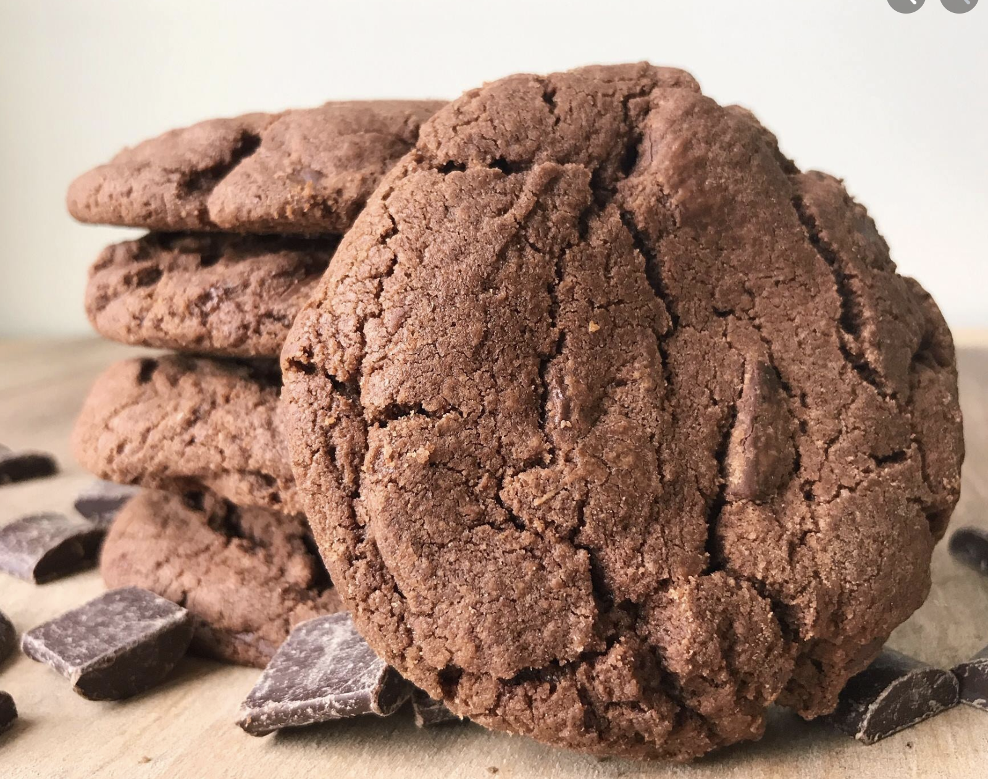
5. double_chocolate_cookies.png
6. My daughter learned to make these cookies at a baking camp at Zingermanns and has tweaked the recipe to fit the taste buds of her siblings. They are extremely sugary so the salt helps to balance it. Note, these cookies are best eaten very quickly.
7. **Recipe Ingredients** 
   1. Unsalted butter
   2. Granulated Sugar
   3. Packed light or dark brown sugar
   4. Large egg
   5. Pure vanilla extract
   6. Semi-sweet chocolate chunks (melted)
   7. All-purpose flour
   8. Natural unsweetened cocoa powder
   9. Baking soda
   10. Salt
   11. Semi-sweet chocolate chunks
8. **Recipe Steps** 
   1. In a mixing bowl cream together the butter, granulated sugar, and brown sugar
   2. Add the egg and vanilla extract and beat well
   3. Add the melted chocolate
   4. In a separate bowl combine the flour, baking soda, cocoa powder and salt
   5. Combine the wet and dry ingredients
   6. Add the unmelted chocolate chunks.
   7. Form 15 cookies and place on a baking sheet.
   8. Cooke for 12 to 13 minutes at 350 degrees.
9. **Additional Food images**
10. double_chocolate_chips.png
11. A small pile of chocolate chips
12. https://images.immediate.co.uk/production/volatile/sites/30/2020/08/chocolate-d9ba778.jpg?quality=90&webp=true&resize=600,545
13. Chocolate melting in a boiler
14. https://upload.wikimedia.org/wikipedia/commons/8/82/Brown_sugar_examples.JPG
15. Brown sugar in three different shades of darkness
16. Colleen van Lent

## Spaghetti

1. **Origin**: Italian,
2. **Source**: own recipe
3. **Category**: Main Dish
4. 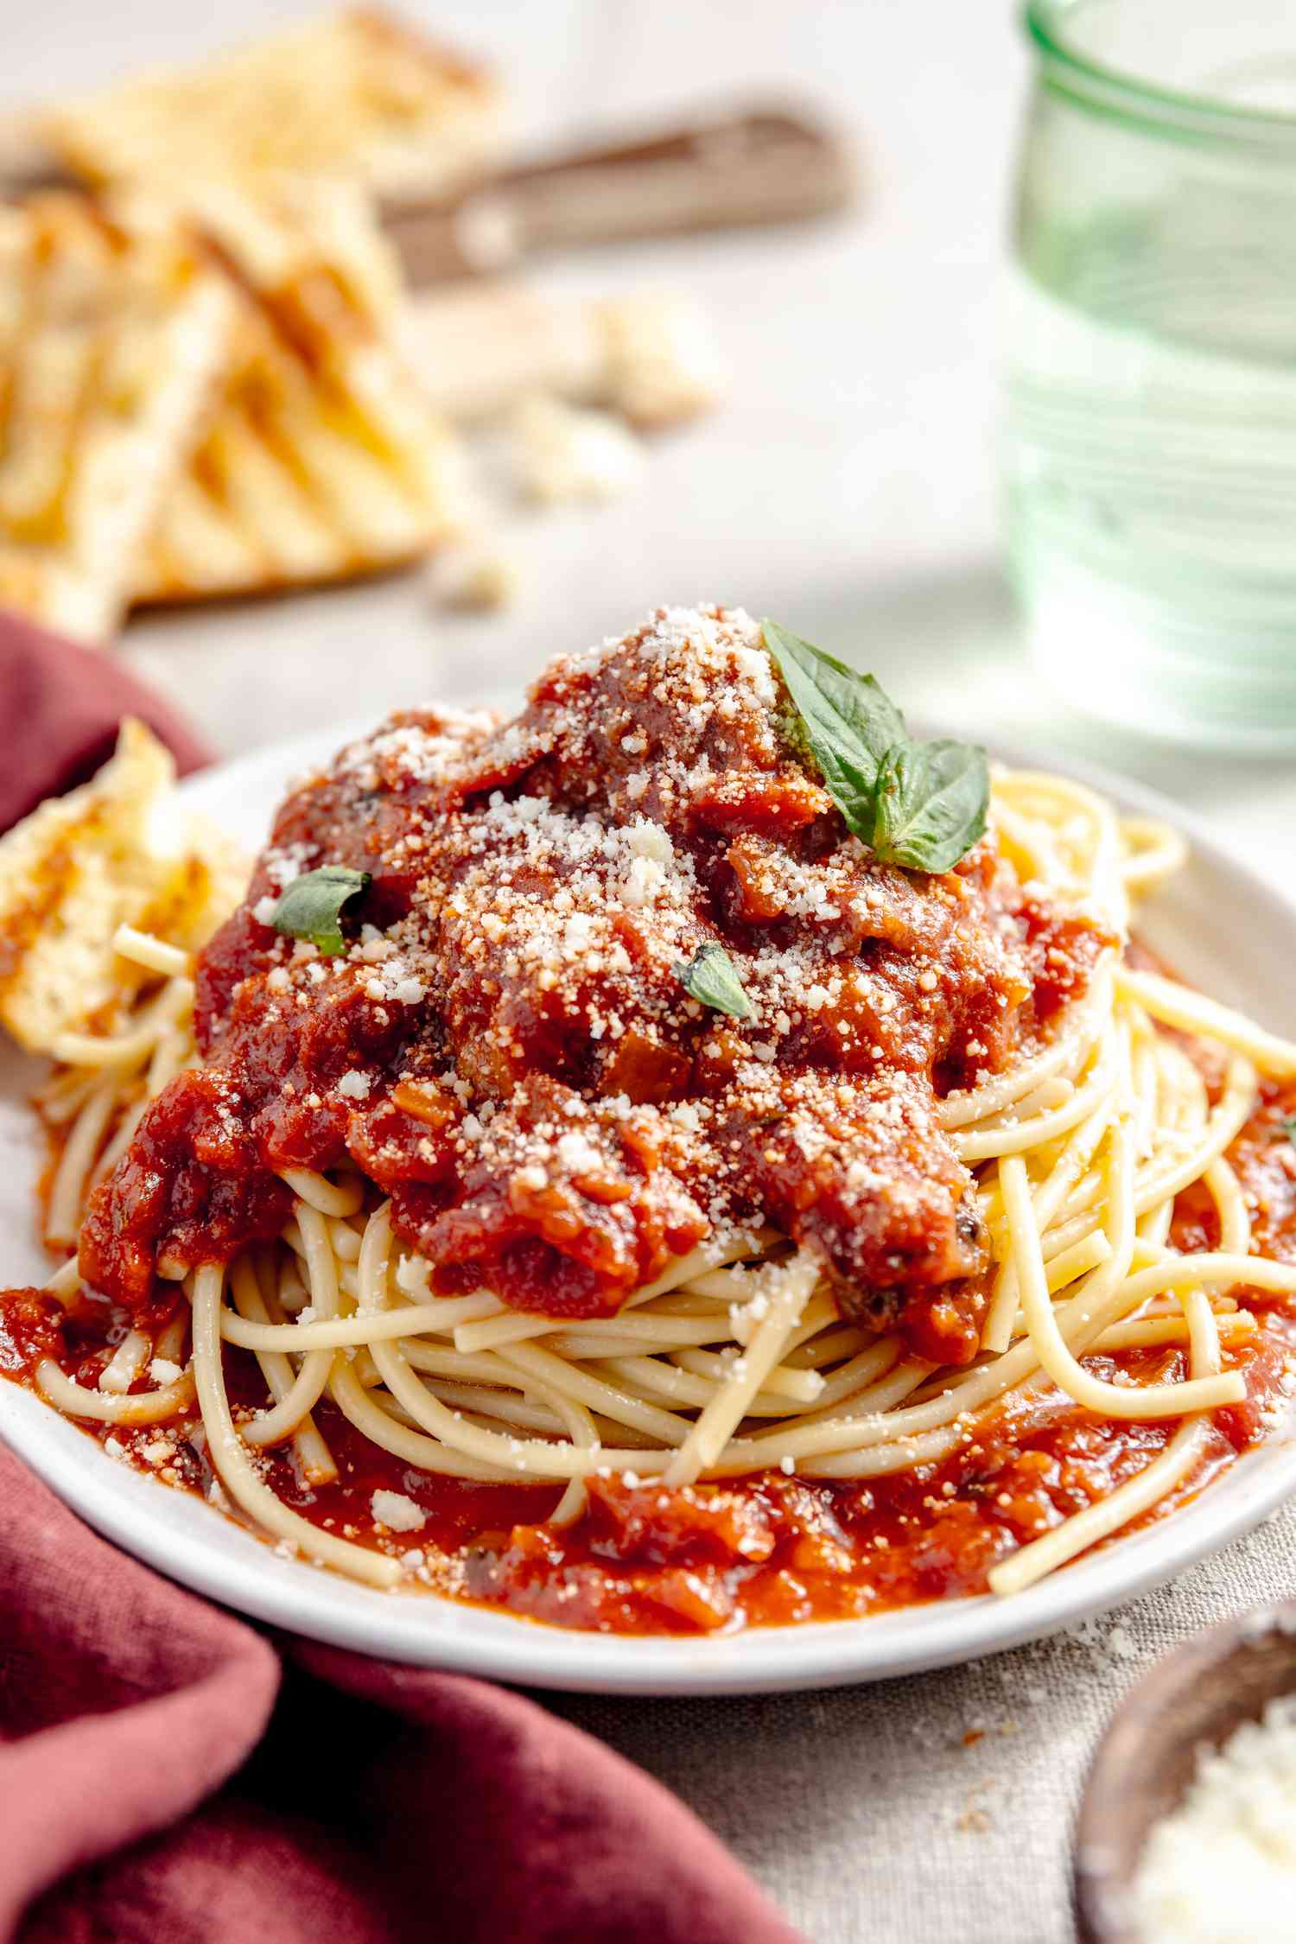
5. spaghetti.jpg
6. Paragraph One about the recipe
7. **Recipe Ingredients – Just write Recipe Ingredients**
   1. Dry spaghetti noodles
   2. Pasta Sauce
   3. Cheese
   4. etc.
8. **Recipe Steps – Just write Recipe Steps**
   1. In a pan, add the pasta sauce and just enough water to cover the bottom of the pan. Bring the mixture to a boil.
   2. Add the spaghetti noodles to the pan and cook according to the packaging instructions
   3. Once the noodles are cooked, plate on a pan and add cheese on top
   4. Step
9. **Additional Food images**
   1. For the next three pictures you can just put the names of the files, you don't have to include the files in this drive, but you do need to add them to the proper Google Drive.
10. spaghetti_sauce.jpg
11. Pasta sauce in a pan
12. spaghetti_noodles.jpeg
13. A pile of dry spaghetti noodles
14. spaghetti_pan.jpg
15. Cooked spaghetti with sauce in a pan
16. Your Name(s)

## Grilled Cheese Sandwich

1. **Origin**: American
2. **Source**: Own Recipe
3. **Category**: Comfort food
4. 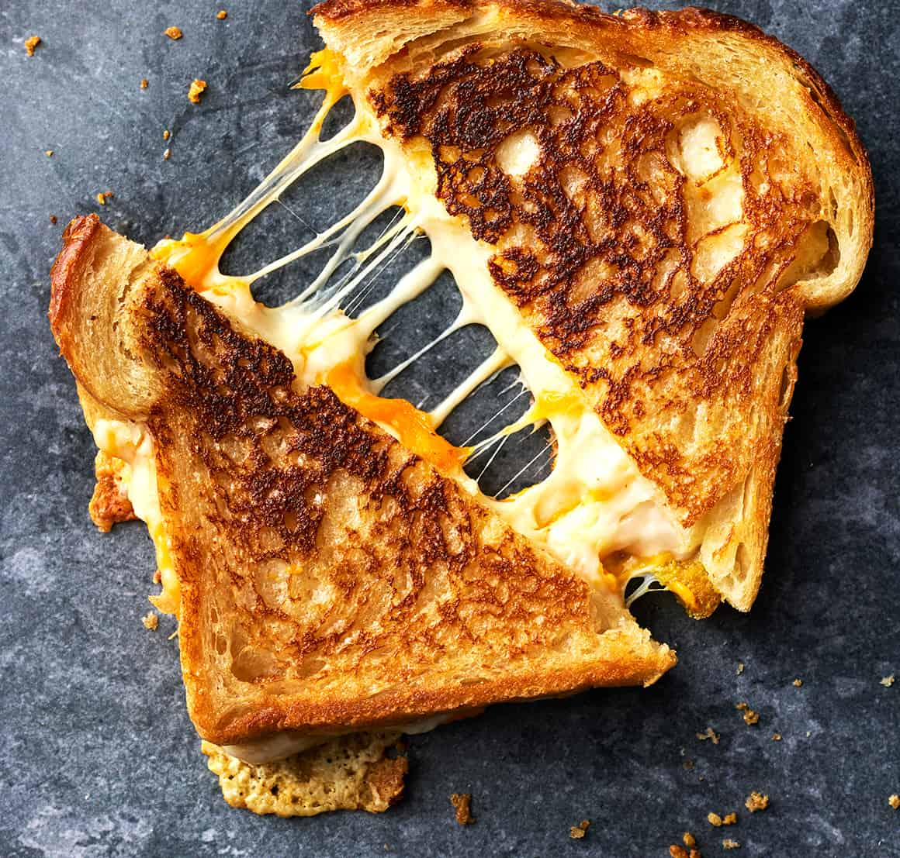
5. grilled_cheese_sandwich.jpg
6. This is a simple recipe perfect for anyone who loves cheese. It would also go great with some tomato soup.
7. **Recipe Ingredients – Just write Recipe Ingredients**
   1. Sliced Bread
   2. Shredded Cheese
   3. Olive oil
   4. etc.
8. **Recipe Steps – Just write Recipe Steps**
   1. In a pan with some olive oil, toast 1 side each of 2 slices of bread
   2. Once toasted, flip the slices over in the pan
   3. Place shredded cheese on 1 of the slices of bread, and then place the other slice of bread on top of the cheese
   4. Continue toasting the sandwich until both sides are golden brown
9. **Additional Food images**
   1. For the next three pictures you can just put the names of the files, you don't have to include the files in this drive, but you do need to add them to the proper Google Drive.
10. grilled_cheese_bread
11. Several slices of white bread in a basket
12. grilled_cheese_cheese
13. Small bowl of shredded cheese
14. grilled_cheese_pan
15. Spatula lifting grilled cheese sandwich in a pan
16. Your Name(s)

## Macaroni and Cheese

1. **Origin**: American
2. **Source**: (Prefer own recipe, but you can add a link here.)
3. **Category**: Main Dish
4. Primary Image of food
5. mac.jpg
6. Paragraph One about the recipe
7. **Recipe Ingredients – Just write Recipe Ingredients**
   1. Dry Macaroni Pasta
   2. Milk
   3. Shredded Cheese
   4. etc.
8. **Recipe Steps – Just write Recipe Steps**
   1. In a pot, combine dry macaroni pasta, milk, and enough water to cover the pasta and bring the mixture to a boil
   2. After the mixture boils, let it simmer until the liquid thickens
   3. Add cheese to the pot and mix
   4. Plate the pasta and top with more cheese
9. **Additional Food images**
   1. For the next three pictures you can just put the names of the files, you don't have to include the files in this drive, but you do need to add them to the proper Google Drive.
10. mac_noodles.jpg
11. Pile of dry macaroni noodles
12. mac_cheese.jpg
13. Shredded, sliced, cubed, and wedged cheeses
14. mac_milk
15. Bottle and glass of milk

## Spaghetti

1. **Origin**: Italian, Korean, Mexican, American, etc, write unknown if unknown
2. **Source**: (Prefer own recipe, but you can add a link here.)
3. **Category**: Main Dish, Vegetarian, Comfort Food, Dessert, etc.
4. Primary Image of food
5. Name of file with food picture (make sure to add the picture to the proper Google Drive!)
6. Paragraph One about the recipe
7. **Recipe Ingredients – Just write Recipe Ingredients**
   1. Ingredient
   2. Ingredient
   3. Ingredient
   4. etc.
8. **Recipe Steps – Just write Recipe Steps**
   1. Step
   2. Step
   3. Step
   4. Step
9. **Additional Food images**
   1. For the next three pictures you can just put the names of the files, you don't have to include the files in this drive, but you do need to add them to the proper Google Drive.
10. file name
11. Visual description of the image/movie
12. file name
13. Visual description of the image/movie
14. file name
15. Visual description of the image/movie